Module 4: The Structure of a Story

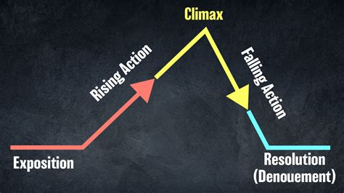
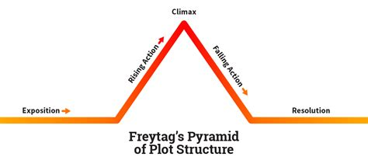
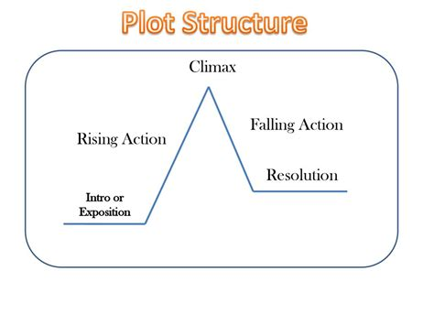
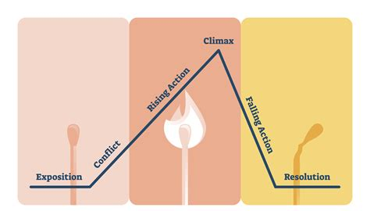

Module Metadata: Structure of the Story (1 Hour)
Short Description
Storytelling follows a structured framework that guides the audience through a journey of emotions, conflicts, and resolutions. Understanding this structure helps storytellers craft compelling narratives that captivate and engage.
Learn how to shape stories that captivate and inspire. This module explores narrative structure, essential story elements, and techniques for crafting compelling, emotionally resonant tales — with applications in education, culture, and creative enterprise.

Long Description
Every powerful story follows a journey — from exposition to resolution, tension to transformation. In this module, learners will explore the anatomy of storytelling through Freytag’s Pyramid and the three-act structure. They’ll unpack key characteristics like character, conflict, and theme, and learn how to build narratives that flow, connect, and leave lasting impact. With practical exercises and assignments, learners will begin crafting stories that not only entertain and educate, but also serve as assets for entrepreneurial ventures — whether in publishing, branding, media, or cultural programming.
Aims
- To introduce learners to foundational storytelling structures and narrative arcs.
- To develop skills in crafting cohesive, emotionally engaging stories.
- To highlight how structured storytelling can be leveraged in creative and entrepreneurial contexts.
Objectives
By the end of this module, learners will be able to:
- Apply Freytag’s Pyramid and the three-act structure to story development.
- Identify and integrate essential story characteristics such as plot, character, and theme.
- Craft compelling narratives with emotional depth and clear progression.
- Explore how structured storytelling supports creative entrepreneurship and audience engagement.

Learning Outcomes
Learners will:
- Demonstrate understanding of narrative structure and storytelling frameworks.
- Create original stories using structured outlines and emotional hooks.
- Analyze how story structure enhances impact in media, education, and branding.
- Begin to position storytelling as a strategic tool for creative enterprise and cultural influence.

The Storytelling Roadmap
A well-structured story follows a five-part narrative arc, often referred to as Freytag’s Pyramid:
- Background (Exposition) – Introduces the setting, characters, and initial situation.
- Rising Action – Develops the conflict, builds tension, and deepens character relationships.
- Climax – The turning point where the protagonist faces their greatest challenge.
- Falling Action – The aftermath of the climax, leading toward resolution.
- Resolution (Denouement) – The conclusion where conflicts are resolved, and the story reaches closure.
This roadmap ensures a natural progression that keeps the audience engaged from beginning to end.
Essential Story Characteristics
A story is defined by key elements that shape its structure and meaning:
- Beginning, Middle, and Ending – Every story follows a clear progression.
- Climax – The peak of tension and conflict.
- Setting – The time and place where the story unfolds.
- Characters – Individuals who drive the story forward, each playing distinct roles.
- Interconnected Events – Events must relate to one another logically.
- Plot Structure – Can be linear (chronological) or circular (returning to the beginning).
- Protagonist vs. Antagonist – The main character faces opposition from an adversary.
- Conflict & Resolution – A problem must be introduced and eventually resolved.
- Philosophical or Metaphorical Depth – Stories can convey deeper meanings beyond surface-level events.
- Purpose – A story can educate, heal, entertain, or achieve all three.
These characteristics ensure that a story is cohesive, engaging, and meaningful.
How to Craft Compelling Narratives
Crafting a compelling story requires intentional structure, emotional depth, and engaging delivery3:
- Start with a Strong Hook – Capture attention immediately with an intriguing opening.
- Develop Relatable Characters – Ensure characters have motivations, flaws, and growth.
- Build Conflict and Suspense – Keep the audience invested by introducing challenges.
- Use Descriptive Language – Engage the senses with vivid imagery and emotions.
- Maintain a Clear Narrative Flow – Ensure logical progression from beginning to end.
- Create an Emotional Connection – Make the audience feel something—joy, fear, hope, or nostalgia.
- End with Impact – Leave a lasting impression through a satisfying resolution or thought-provoking conclusion.
A compelling narrative immerses the audience and leaves them wanting more.
Exercise: Write a Simple 3-Act Story
Instructions:
Write a short story following the three-act structure:
- Act 1: Setup
  - Introduce the protagonist, setting, and initial conflict.
  - Establish the stakes and the character’s goal.
- Act 2: Confrontation
  - The protagonist faces obstacles and challenges.
  - Rising tension leads to the climax.
- Act 3: Resolution
  - The protagonist either succeeds or fails.
  - The story concludes with a lesson or emotional payoff.
Example Prompt:
"Write a short story about a young artist struggling to find inspiration. How does their journey lead to a breakthrough?"

Exercise: Create a story outline using the five key elements: Background, Rising Action, Climax, Falling Action, and Resolution.
Assignment: Write a short story (300–500 words) using this structure.

